Why would the law interfere with such a majestic scene?
Take a look below this pic for the surprise answer!

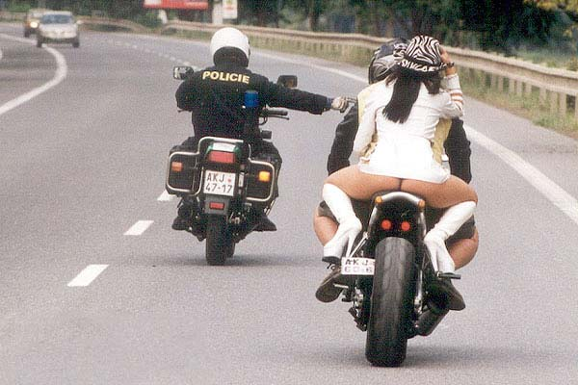

^
^
^
^
^
^
^
^
^
^
^
^
How long did it take you to figure out that the rear passenger wasn’t wearing a helmet!

